**Service Specific Profile** 

**Project Leader (Potteries)**

*This document is to be read alongside the main Project Leader job description and provides additional information relating to this service.*

# Job Purpose

You will provide leadership and day-to-day supervision in one of our thriving social enterprise potteries. Each service supports up to 30 people with learning disabilities and autism every week,

* **Banwell Pottery, @Worle Sports Centre, WSM** is a purpose-built design studio providing supported employment and training opportunities

Everything we produce is designed and made by the people we support including individually designed hangers, and coasters. We sell our products from our studio as well as craft and art fairs across North Somerset and Bristol and also from the growing number of Brandon charity shops. In addition, we also have a thriving evening Hobby Class running each week open to the public.

* **Fired Up, Yate** is a ceramic studio-based environment offering person-centred training opportunities with a focus on ceramic production.

Individuals are enabled to develop skills and experience within a thriving creative environment while developing and expanding as a Social Enterprise. We have a range of products that we design and develop to sell from the studio and attend a variety of art & craft events. In addition, we have 2 thriving Hobby Classes running each week open to the public, we offer a kiln firing service to members of the public, we host numerous workshops both on site and externally and we also provide painting parties and birthday parties to adults and children.

These are the things you will do to make this happen:

You will provide leadership and supervision to the team while working alongside them carrying out the activities within the studio and through formal staff coaching, supervision, appraisal, and performance management.

You will identify areas of personal development for yourself and your staff team.

You will work alongside the Project Coordinator in the development of the project and support the production work including the correct use of clay, glazes, and other ceramic materials consistently and to agreed levels.

You will develop and implement marketing activities and opportunities to increase sales, promote the studio and the services we offer, this may be at weekends and evenings.

Develop links with the local community

You will ensure that support workers act in accordance with regulations and Brandon Policy, instructing them and directing them towards appropriate sources of information.

You will actively support your manager and Brandon in the development and implementation of plans to achieve and sustain excellence within your service.

You will supervise and monitor the proper and effective use of the financial and other resources available to the service.

You will ensure that your manager receives such information concerning the welfare of people supported and the performance of employees that they require to fulfil their responsibilities.

You will develop and maintain good relationships with other agencies.

# Key Responsibilities

* Provide leadership, support, and direction to a small team of support workers.
* Carry out varied tasks linked to ceramic production.
* Work alongside the Project Coordinator in developing and creating new designs and products.
* Ensure all people we support in the project have relevant outcomes set and progress towards these are monitored regularly.
* Facilitate and support the reviews for people we support 6 monthly and annually.
* Ensure health & safety procedures are explained, implemented, and followed at all times.
* Undertake marketing and promotional activity where necessary to increase sales and attract new business.
* Provide quantitative and qualitative reports relevant to your role.
* To engage with and support the project coordinator with the necessary input required for 6 monthly auditing of the Enterprise
* Deliver excellent customer service.
* Work with the Project Coordinator to keep the project within its budget, keeping a record of and monitoring expenditure and income.
* Work in accordance with the key policies and procedures of Brandon Trust

**Key Relationships**

People with learning disabilities, families and carers, other Brandon staff, retail staff team , customers/contractors, suppliers, other organisations, social workers, and other professionals.

Brandon values and behaviours

* + Take a person-centred approach

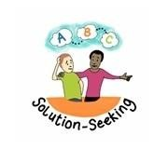

* + Help people to make choices
  + Bring out the best in people
  + Respect people’s differences
  + Friendly, kind, and compassionate
  + Ask questions
  + Take a coaching approach
  + Show resilience
  + Plan effectively
  + Set high standards
  + Take considered risks
  + Make things happen
  + Try new things
  + Push for change
  + Have a ‘can-do’ attitude
  + Connect people
  + Make links to improve things
  + Can work with all types of people
  + Can spot opportunities for growth ▪ A team player

* + Flexible and creative
  + Use imaginative ideas to solve problems
  + Can bring new perspectives ▪ Think outside the box

# Brandon leadership behaviours

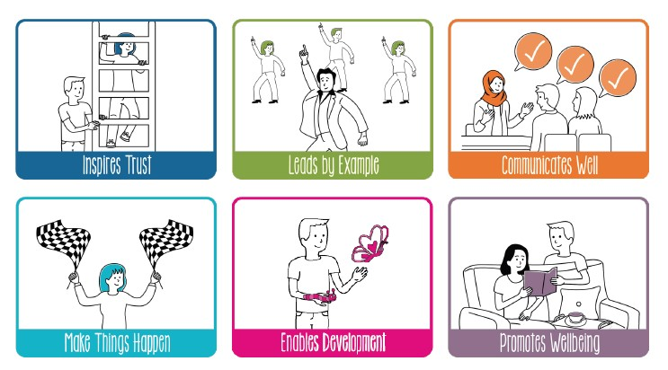

**Person specification:**

**Project Leader (Potteries)**

## Core requirements Service specific requirements

|  |  |  |
| --- | --- | --- |
| **Qualifications** |  |  |
| * Maths and English qualifications at GCSE (grade A-C) level or equivalent OR be able to demonstrate competence at this level through assessment * *Diploma in health and social care (level 2) or equivalent (Desirable)* | •  • | Level 2 Ceramic/Art qualification or able to demonstrate equivalent knowledge/skills  Full driving licence with own transport, able and willing to use this for work *(Desirable)* |
|  | • | *Additional relevant qualifications*  *(Desirable)* |
| **Experience** |  |  |
| * Proven track record of managing a staff team or project. * Working in small business or social Enterprise. * Managing a budget * Customer service, including dealing with complaints or difficult situations * Networking, promotion and identifying and developing new opportunities/initiatives * *Working with people with learning disabilities and autism (Desirable)* * *Relevant experience of commercial promotions, marketing, sales (Desirable)* * *Relevant experience of guiding / training / teaching others (Desirable)* | •  • | Knowledge and experience of Art & Ceramics.  Demonstratable experience of designing, making, and selling ceramics on a commercial basis.  Demonstratable knowledge and experience of using social media platforms for business marketing and promotion. |
| **Skills / Personal Attributes** |  |  |
| * Able to lead, inspire, motivate, direct and support your team. * Demonstrates excellent teamwork. * Enthusiastic about working with, motivating and supporting staff and trainees with learning disabilities * Commercial awareness * Creative approach and ability to support the development of the project. • * Innovative problem solver, willing to try new activities, adaptable * Able to flex working patterns * Excellent verbal and written communication skills * Good IT skills and ability to use a variety of programs. * Patience and excellent customer service skills * Ability to work under pressure, meet deadlines and manage time effectively. * Approachable, cheerful and calm * Demonstrates Brandon values with an attitude towards others based on respect, dignity, and equality. |  |  |