
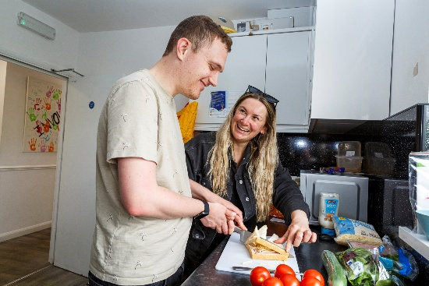




Support worker- Brandon Packaging

Purpose

Deliver high-quality, person-centred support within the Enterprise Brandon Packaging social enterprise, ensuring individuals with learning disabilities achieve their commissioned outcomes while supporting the accurate, safe, and timely production of transplant kit orders.

Quality Support for People with Disabilities
Provide day-to-day support to supported employees and trainees; ensure reviews, outcomes, and support plans are maintained and delivered effectively.

Production & Distribution Operations
Ensure all NHS kit orders are packed and dispatched safely, accurately, and within deadlines; contribute to quality control, stock checks, procurement and record-keeping.

Customer Service & Reporting
Maintain excellent customer service; contribute to monthly reporting; record and act on customer concerns and complaints.

Commercial & Service Development
Work with the Project Leader to identify opportunities that increase employment pathways for people with learning disabilities.

Person Specification

Experience
• Experience in social enterprise or non-profit settings (desirable)
• Supporting people with learning disabilities into work (highly desirable)
• Packaging/distribution environment experience (desirable)

Skills
• Strong verbal and written communication skills
• Highly organised and efficient
• Patient, approachable, cheerful, reliable and punctual
• Competent with Excel, Word, OneDrive and SharePoint

Skills and behaviours you need for this role

CORE SKILLS

Skill | Level required  for role |  |  |  |  | What this means
Data Literacy |  |  |  |  |  | People at this level can use data tools and follow GDPR rules to help understand what is happening in the organisation.
Digital Skills |  |  |  |  |  | People at this level choose and develop digital tools, promote secure working practices, and support innovation across their teams.
Governance and Compliance |  |  |  |  |  | People at this level lead governance and compliance activity, making sure good practice is followed in everyday operations and in planning.
Commercial Awareness |  |  |  |  |  | People at this level help manage budgets, track spending, and support good financial decisions.
Health and Safety |  |  |  |  |  | People at this level use health and safety rules in their everyday work and help maintain a safe and healthy  environment.
Inclusion |  |  |  |  |  | People at this level embed inclusive practice into planning, decision‑making, and team culture. They help create spaces where everyone can contribute and feel  valued.

BEHAVIOURS - VALUES

Behaviour | Level required for role |  |  |  |  | What this means
Equip |  |  |  |  |  | People at this level prepare well and work in a steady, organised way. They make sure others can get the right information and that work runs smoothly.
Involve |  |  |  |  |  | People at this level make sure others are involved in  conversations, teamwork, and making decisions.
Support |  |  |  |  |  | People at this level give strong support and encouragement to  others. They help create a workplace where everyone feels  valued, included, and able to grow.
Recognise |  |  |  |  |  | People at this level use clear communication, good listening,  and quick responses in their everyday interactions.
Challenge |  |  |  |  |  | People at this level take responsibility, try new ideas, and  adapt well to change to help work move forward.

SPECIALIST SKILLS

Skill | Level required for role |  |  |  |  | What this means
Order and Hospital Liaison |  |  |  |  |  | People at this level confirm and record order details correctly, prioritise by urgency and courier times, and keep simple updates flowing to the team.
Labelling Accuracy |  |  |  |  |  | People at this level uphold labelling standards, prevent  repeat errors, and coach others in layout, sequence and quality checks.
Kit Assembly & Dispatch |  |  |  |  |  | People at this level assemble in the correct sequence, label and seal accurately, book couriers and record dispatch details  without errors.
Equipment, Health & Safety |  |  |  |  |  | People at this level work safely without supervision, follow  simple risk controls and keep others safe around them.
Stock Handling & Storage |  |  |  |  |  | People at this level plan space and stock levels, solve  shortages quickly, and keep records reliable for traceability  and ordering.
Ordering Stock & Supplier Liaison |  |  |  |  |  | People at this level help count and tidy stock, pass on  low‑stock notes, and handle boxes safely when asked.

COMPETENCIES

Behaviour | Level required for role |  |  |  |  | What this means
Active Listening |  |  |  |  |  | People at this level listen with care in everyday conversations and reply in ways that help people work well together and build trust.
Attention to detail |  |  |  |  |  | People at this level produce accurate work on a regular  basis and make sure all key details are included.
Reliability |  |  |  |  |  | People at this level manage their own workload reliably,  meet expectations, and follow through on commitments.
Teamwork |  |  |  |  |  | People at this level actively contribute to team goals and  work effectively with colleagues.
Problem Solving |  |  |  |  |  | People at this level identify and resolve problems efficiently  using structured thinking.
Verbal Communication |  |  |  |  |  | People at this level communicate clearly and confidently in everyday conversations, adapting to different people and situations.
Empathy |  |  |  |  |  | People at this level show empathy in daily interactions  and adjust how they behave to support others.
Emotional Intelligence |  |  |  |  |  | People at this level use their awareness of emotions to  communicate well and build positive working relationships.
Time Management |  |  |  |  |  | People at this level managetheir own workload reliably,  prioritising and planning effectively to meet expectations.
Flexibility |  |  |  |  |  | People at this level adapt well to daily changes in priorities,  tasks, and team needs.
Customer Centric |  |  |  |  |  | People at this level work to give customers a good experience  and sort out issues in a clear and helpful way.

