
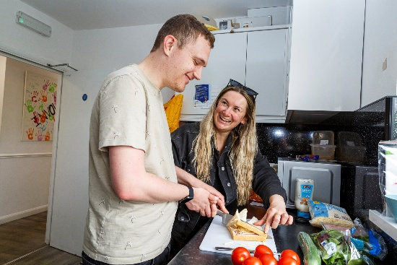
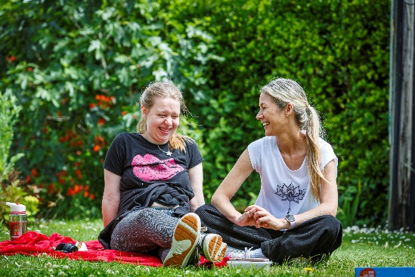

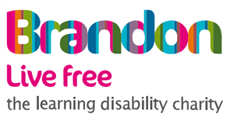

Team Leader (Nurse)

Purpose:

The purpose of this role is to provide specialist clinical nursing support that enables people with learning disabilities to experience safe, high quality, person centered care. Staff Nurses use their professional expertise to promote health, wellbeing, and independence, ensuring each person receives the right clinical interventions at the right time.-

Objectives:
Clinical Practice & Health Outcomes
- Deliver safe, evidence-based nursing care that meets assessed health needs and improves outcomes.
- Carry out nursing procedures in line with NMC standards and clinical guidelines.
- Monitor health changes and escalate concerns to prevent deterioration.
- Ensure Health Action Plans and Care Plans are current and effective.
- Promote safe, positive risk-taking to maintain independence.
Professional Leadership & Role Modelling
- Provide visible clinical leadership and model excellent practice.
- Coach colleagues to build capability in health-related support.
- Support newly qualified nurses through preceptorship.
- Champion Brandon Trust values and challenge poor practice.
Independence, Skills Development & Personal Outcomes
- Work with individuals to set and review personal health and independence goals.
- Support informed decision-making through accessible communication.
- Enable people to build skills in managing their own health.
- Advocate for rights and best-interest decisions under the MCA.
Communication, Advocacy & Relationships
- Build positive, trusting relationships with individuals and families.
- Communicate clinical information respectfully and clearly.
- Represent individuals’ voices in multidisciplinary forums.
- Act as a clinical point of contact for external professionals.
Safety, Quality & Compliance
- Maintain accurate, timely clinical documentation.
- Comply with safeguarding responsibilities.
- Support CQC and regulatory compliance.
- Promote high standards of infection control and medication safety.
Teamworking & Service Improvement
- Work collaboratively with colleagues and professionals.
- Contribute to service reviews and improvement initiatives.
- Provide clinical insight for planning and risk management.

Key Relationships
- People we support
- Support Workers
- Support Managers
- Locality Managers
- Clinical Lead
- External medical and social care professionals
- Families

Skills and behaviours needed for this role

CORE SKILLS

Skill | Level required  for role |  |  |  |  | What this means
Data Literacy |  |  |  |  |  | People at this level can use data tools and follow GDPR rules to help understand what is happening in the organisation.
Digital Skills |  |  |  |  |  | People at this level use a range of digital tools and follow online safety rules to help their team work smoothly and safely.
Governance and Compliance |  |  |  |  |  | People at this level use governance and compliance rules in their daily work to help keep the organisation safe and responsible.
Commercial Awareness |  |  |  |  |  | People at this level help manage budgets, track spending, and support good financial decisions.
Health and Safety |  |  |  |  |  | People at this level use health and safety rules in their everyday work and help maintain a safe and healthy environment.
Inclusion |  |  |  |  |  | People at this level use inclusive behaviours in everyday work and make sure others feel welcome and involved.

SPECIALIST SKILLS

Skill | Level required for role |  |  |  |  | What this means
Safeguarding |  |  |  |  |  | People at this level can apply their knowledge of safeguarding effectively in practice. They take immediate action and provide support when a concern arises.
Person Centred Practice |  |  |  |  |  | People at this level consistently apply person-centred principles in their practice. They ensure that care is genuinely reflective of the individual’s choices, needs, and goals.
Mental Capacity |  |  |  |  |  | People at this level can apply their knowledge of mental capacity in practice. They can assess capacity, document findings, and make decisions in accordance with the Mental Capacity Act.
Restrictive Practices and DoLS |  |  |  |  |  | People at this level have a deeper understanding of restrictive practices and DoLS. They understand the situations in which restrictive practices may be necessary and the safeguards that must be in place to ensure their use is legal and appropriate.
Leading and Managing Partnerships in Adult Care |  |  |  |  |  | People at this level understand the principles of managing partnerships and how to work with others in a coordinated way. They are familiar with the processes involved in developing and maintaining effective partnerships in adult care.
Duty of Care |  |  |  |  |  | People at this level are able to apply their understanding of duty of care effectively in practice, balancing the needs of individuals with the legal and organisational responsibilities they have.
Compliance Recording |  |  |  |  |  | People at this level consistently apply compliance standards and recording procedures in their day-to-day practice. They take an active role in ensuring their work aligns with regulatory and organisational requirements.

BEHAVIOURS - VALUES

Behaviour | Level required for role |  |  |  |  | What this means
Equip |  |  |  |  |  | People at this level prepare well and work in a steady, organised way. They make sure others can get the right information and that work runs smoothly.
Involve |  |  |  |  |  | People at this level make sure others are involved in conversations, teamwork, and making decisions.
Support |  |  |  |  |  | People at this level give strong support and encouragement to others. They help create a workplace where everyone feels valued, included, and able to grow.
Recognise |  |  |  |  |  | People at this level use clear communication, good listening, and quick responses in their everyday interactions.
Challenge |  |  |  |  |  | People at this level take responsibility, try new ideas, and adapt well to change to help work move forward.

COMPETENCIES

Behaviour | Level required for role |  |  |  |  | What this means
Empathy |  |  |  |  |  | Shows empathy consistently in daily interactions and adjusts behaviour to support others.
Attention to Detail |  |  |  |  |  | Works accurately and consistently, making sure important details are correct even when under pressure.
Collaboration |  |  |  |  |  | People at this level use structured collaboration to shape plans, decisions, and improvements, especially when change or impact is significant
Co-Production |  |  |  |  |  | Actively involves people we support and colleagues in shaping work and decision making processes.
Crisis Management |  |  |  |  |  | Manages crises effectively by applying problem-solving and maintaining composure under pressure.
Decision Making |  |  |  |  |  | Makes informed and confident decisions within their role.
Planning and Organising |  |  |  |  |  | Plans and manages tasks well, ensuring work is completed efficiently.
Stakeholder Management |  |  |  |  |  | Actively contributes to team goals and works well with colleagues.
Verbal Communication |  |  |  |  |  | Uses verbal communication effectively in a range of formal and informal settings to inform, influence, or resolve.
Time Management |  |  |  |  |  | Balances multiple priorities confidently and supports others in managing time and workload.

